**MESD Documentation LMS-36-Content-Format-Supportability**

**Purpose**

To allow for the right types of file to be put in the system, without conflict for a seamless learning experience

**Background**

The MESD LMS will have to have a lot of content on the site, and a lot of it will be in different formats. By managing those formats and creating support for them then there won’t be any issue with accessing and interacting with the content that is put up.

**Setting File Types**

An administrator can add new file types and view, edit and delete existing file types from Site administration > Server > File types. This means that, for example, if teachers and students on your site use a lot of files specific to a particular program, such files can now be recognized by Moodle, and, when downloaded, they will open in the correct program, rather than presenting themselves as a generic zip file.

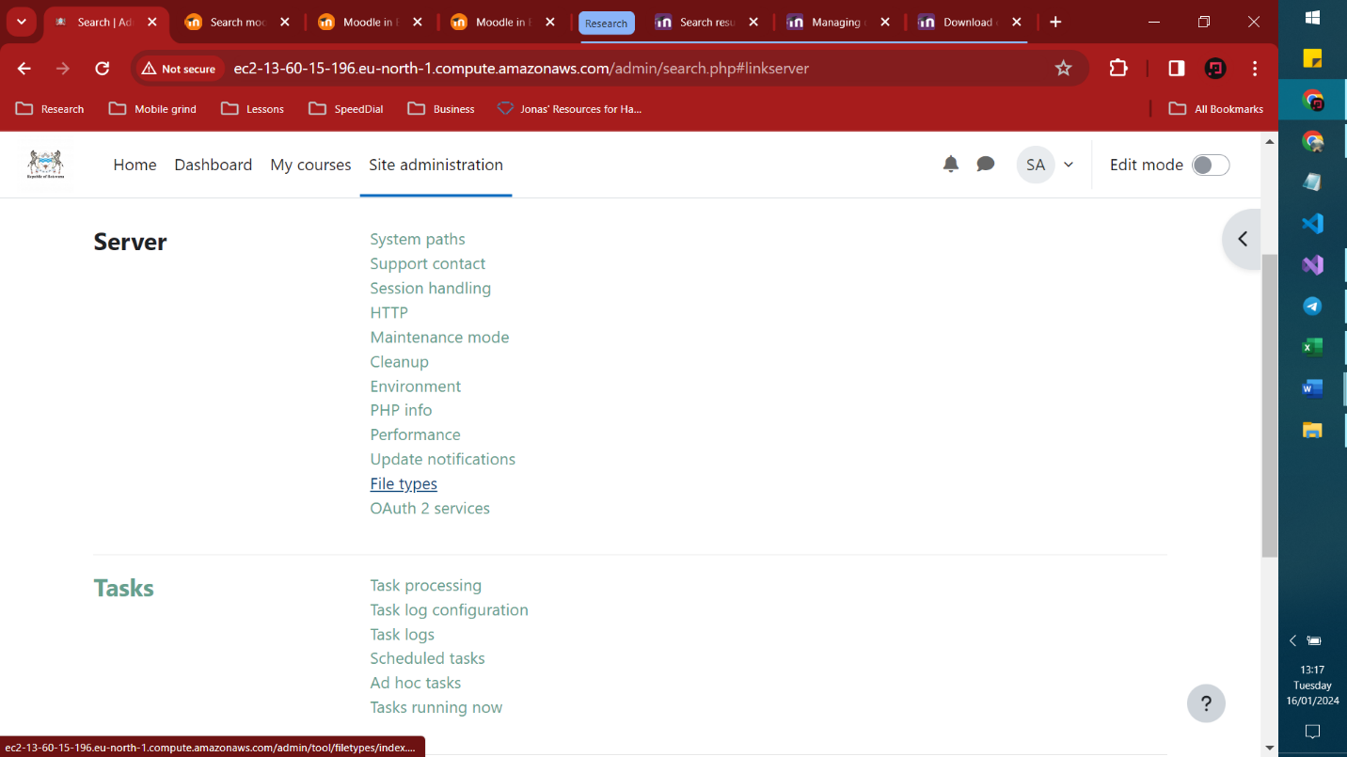

From there one can add or remove the file type that the site uses.  
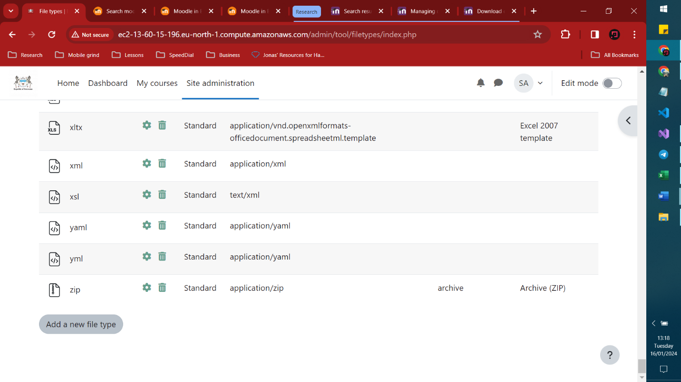

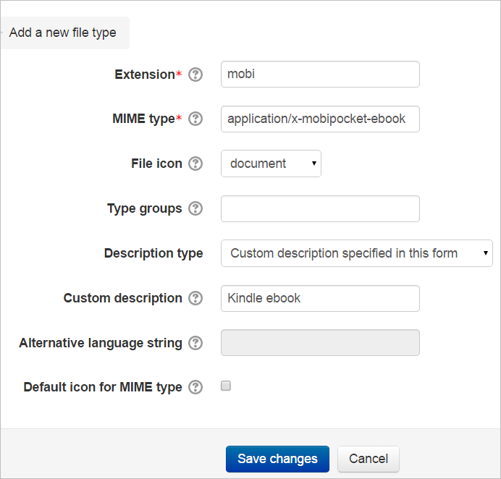

The MIME type is important as it helps Moodle to identify the file type when it is uploaded.

**Restricting file types**

To restrict allowed file types for specific activities like assignments or workshops, you can set these restrictions in the activity settings. For example, in an assignment activity, you can define the accepted file types within the Assignment settings. (Usually accessed in edit mode)  
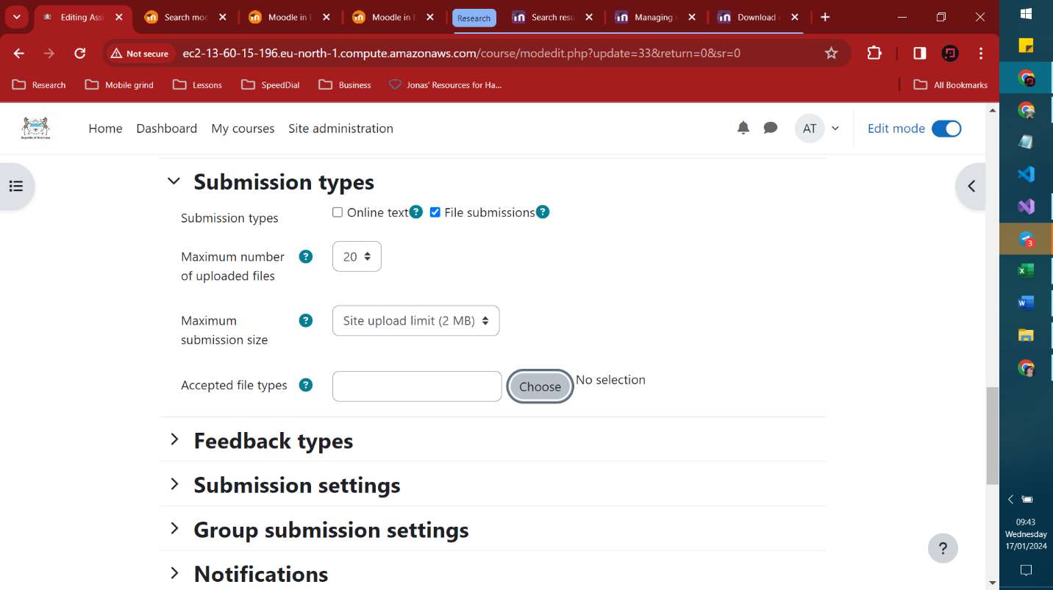  
  
By choosing the accepted file types you ensure that there will always be compatability  
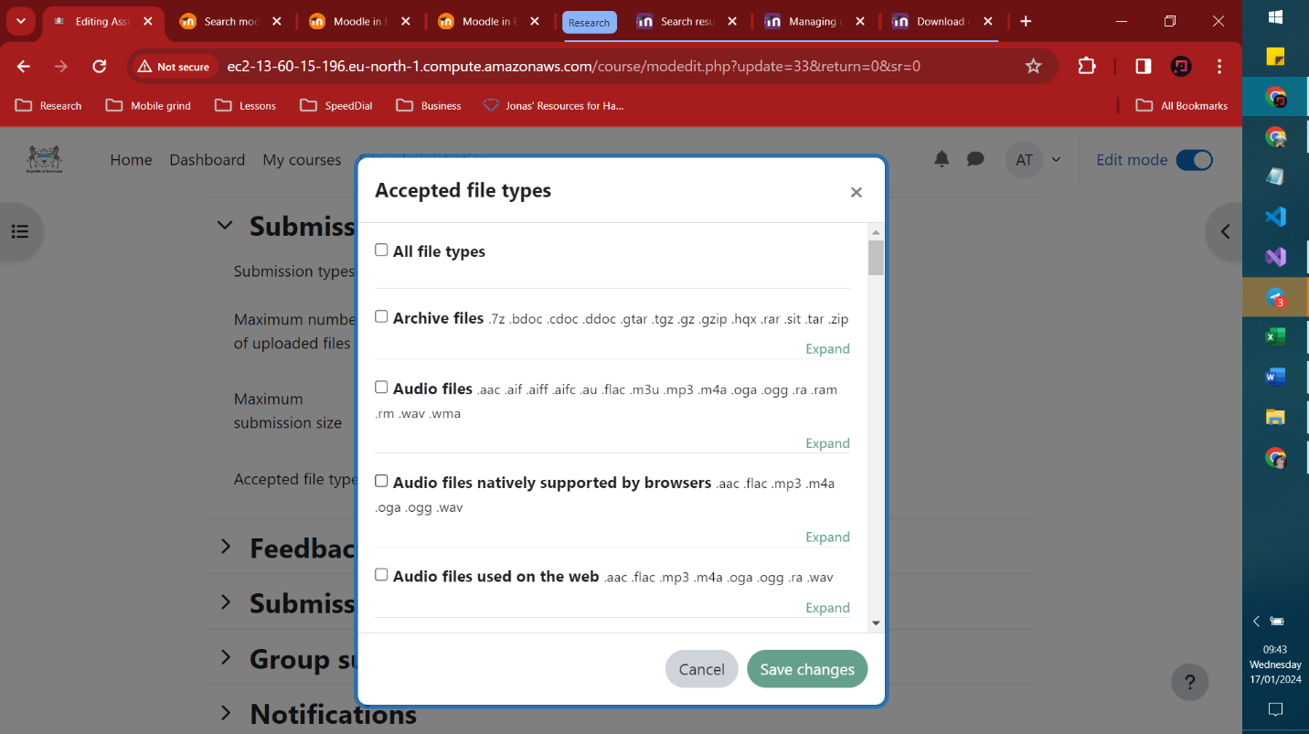  
  
If you happen to be putting content up on the site that doesn’t seem to work even if it’s the same acceptable format, try to follow this discussion for information <https://moodle.org/mod/forum/discuss.php?d=317841>